

河北众诺起重机械制造有限公司

aa ® ^ M ^e^e, Zhongnuo Lifting Machinery Manufacturing Co.f L td.

ZH0N6NU0DIAQCHENG

**Qualified win-win and keep pace with the times**

COMPANY PROFILE

Hebei Zhongnuo Lifting Machinery Manufacturing Co.; Ltd. is a member unit of China Weighing Instrument Association. It has passed the ISO 9001 (2000) international quality management system and certification.

The company is located in Baoding, a new international logistics city, at the core of North China Highway Network. It was established in August 2006 and is a national certified electronic scale production and sales enterprise in Hebei Province.

At present, the main products of production and operation are: 0.3t~50t direct-looking scale; 3t-100t wireless scale; various professional and special scale. The LOAD CELL used by 2T-3T hydraulic conveyor scale is a product produced by excellent sensor manufacturers at home and abroad, with reliable quality. Our products are sold all over the world.

Hebei Zhongnuo relies on technological progress, continuous innovation, adheres to people-oriented, and takes customer satisfaction as the criterion. We will exchange first-class products and perfect services for user's love.

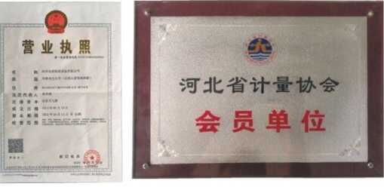Company Certificate

营业执照

AS B* 督逢爾* 鎌雷it篇

题

%

会员单位

河北众似

二食九巾-

t鄉公司

会员证书

河北众诺起重机械制造有限公司

中国衡器协会会员单位

中田游器协会

有效期i 2019年丨2月 二O^AV-十月

河北众诺起重机械制造有限公司

Hebei Zhongnuo Lifting Machinery Manufacturing Co.f Ltd.

吊视

ZH0N6NU0DIA0CHEN6

直视高精度(OCS-SE 2t-15t>

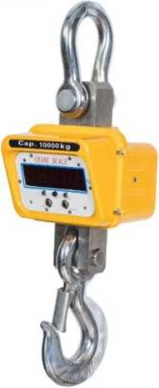Main Performance

1. Two pieces of 8.4V4 .0 AH lithium batteries, one is built-in, another is spare part
2. Metal panel, stainless steel keys
3. Die-cast aluminum shell, beautiful and anti-corrosion 4.5 digital(30mm) LED display,red and green optional 5.Turn on / off with automatic display of battery voltage 6.1nfrared remote control, easy to operate,enhanced function

7丄ow energy consumption design for mainboard, extended use time 8.0verload and low voltage warning

9.Good dynamic weighing performance, not affected by shaking

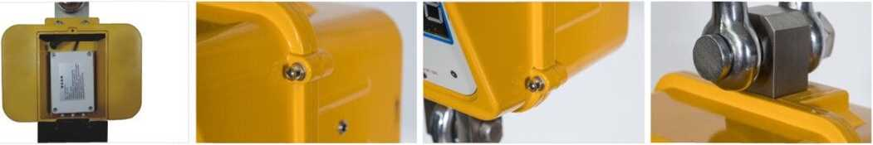

Specification

|  |  |
| --- | --- |
| | Accuracy Class | OIMLffl |
| Working Time | standby 180 hours |
| Safe Overload | 125%F.S |
| Limited Load | 300%F.S |
| Work Temperature | -20〇C+50〇C |
| Indicator Specification | 1.2" |
| Remote Control Distance | 6-10 m |

Optional accessories

weight KG

|  |  |  |  |  |  |  |  |  |  |  |  |
| --- | --- | --- | --- | --- | --- | --- | --- | --- | --- | --- | --- |
| 2T | 2000KG | 0.5kg | 255 | 190 | 215 | 610 | 100 | 50 | 45 | 30 | 11.4 |
| 3T | 3000KG | 0.5kg | 255 | 190 | 215 | 610 | 100 | 50 | 45 | 30 | 11.4 |
| 5T | 5000KG | 1kg | 255 | 190 | 215 | 690 | 120 | 75 | 55 | 35 | 16.8 |
| 10T | 10000KG | 2kg | 255 | 190 | 215 | 750 | 125 | 85 | 70 | 45 | 24.4 |
| 15T | 15000KG | 2kg | 255 | 190 | 215 | 910 | 180 | 100 | 80 | 55 | 34.6 |

